Half Subtractor :-
A half subtractor is a combinational logic circuit that subtract two bits at a time and produces their different.
It has two inputs minuend (A) & subtrahend (B) and two outputs difference and borrow.
The difference is a result of subtraction & borrow is used to indicate borrow from next most significant bit. The borrow bit is present only when A < B .

Truth table :-
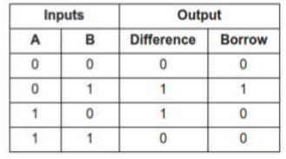
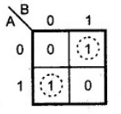
K- Map for Difference

K – Map for Borrow
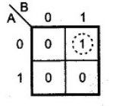

Expression from the K - Map
Difference = AB’ + A’B
Borrow = A’B

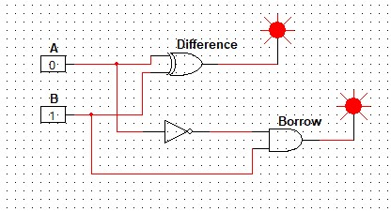
Logical diagram :-

